**COMP416 PROJECT-1 PART-1 REPORT**

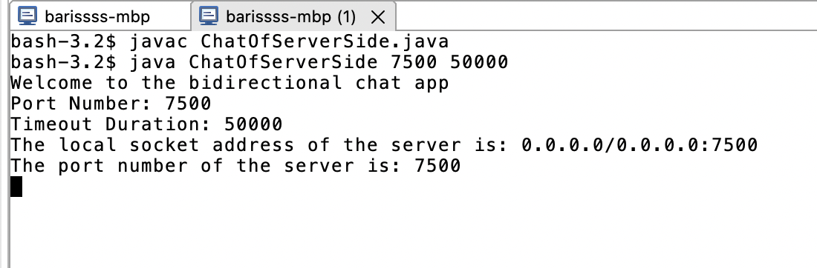**Name-Surname:** Barış Kaplan , **KU ID Number:** 0069054

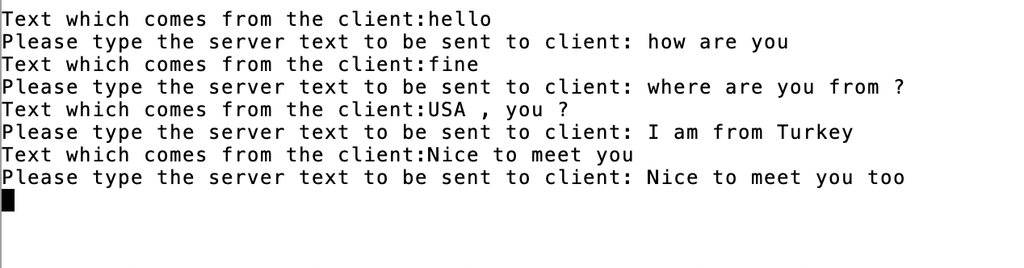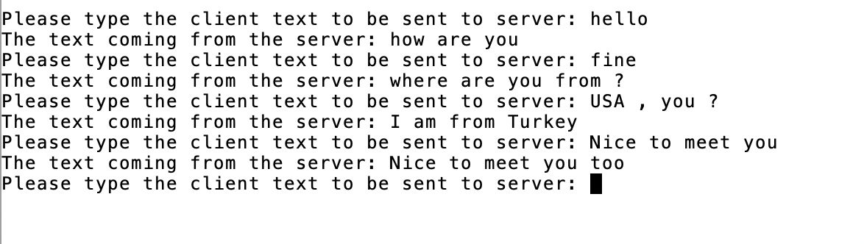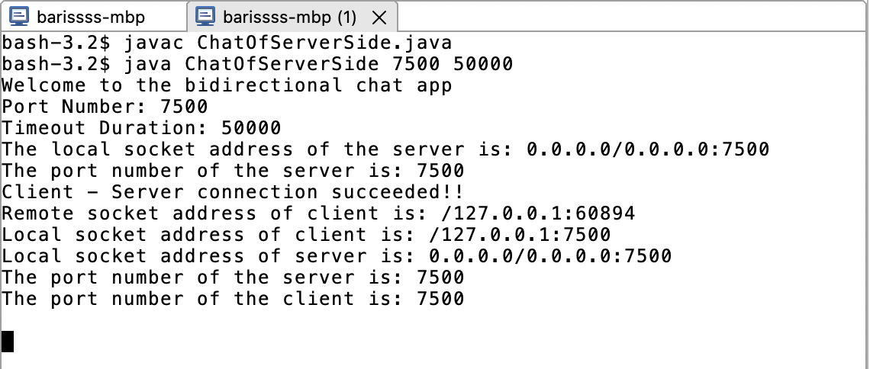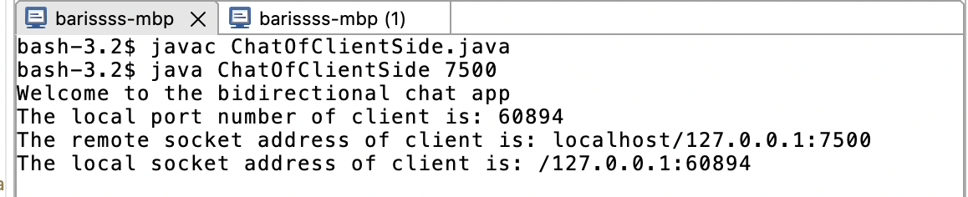

Figure 3: The screenshot which shows the remote socket address of the client , the local socket address of client, the local socket address of server, the port number of server, and the port number of client (This screenshot is taken from the server-side terminal).

Figure 5: The screenshot which shows the chat in the server (This screenshot is taken from the server-side terminal).

Figure 4: The screenshot which shows the chat in the client (This screenshot is taken from the client-side terminal).

Figure 2: The screenshot which shows the local port number of client, the remote socket address of the client, and the local socket address of the client (This screenshot is taken from the client-side terminal).

Figure 1: The screenshot which shows the port number and the timeout duration given as arguments from the console. (This screenshot is taken from the server-side terminal). Here, the first argument is the port number (Port number = 7500). Moreover, the second argument is the timeout duration (Timeout duration = 50000 ms).

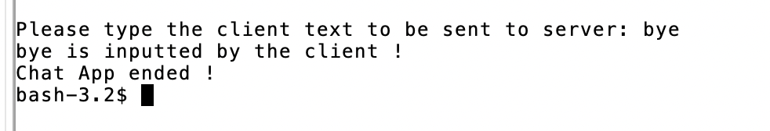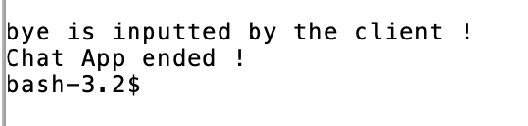

Figure 7: This screenshot is taken from the server-side terminal. Here; after client enters bye to terminal, server is informed from that. Then, at the end of the program, the messages in this screenshot are displayed in the server-side terminal

Figure 6: The screenshot which shows the keyword I used to end the chat, and the messages displayed at the end of the chat (This screenshot is taken from the client-side terminal).

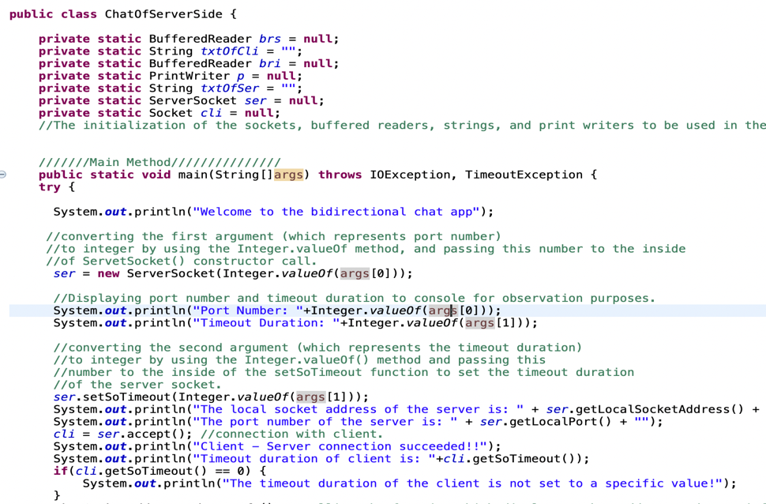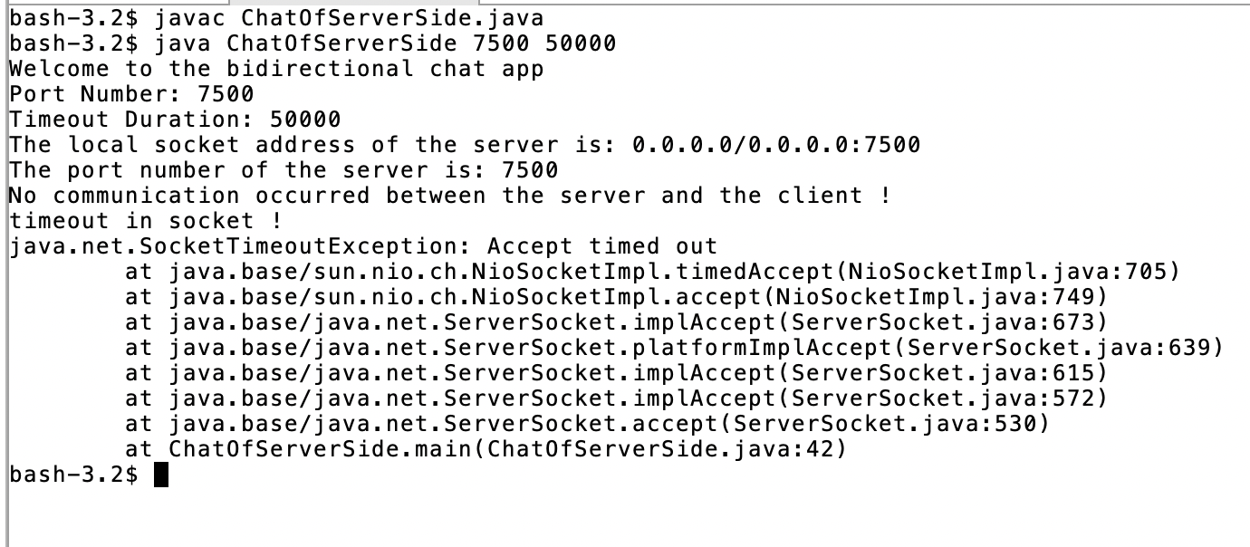

Figure 8: The screenshot which shows the timeout in server and the messages displayed after timeout (This screenshot is taken from the server-side terminal). (In this case, there is no client which is connected to the server.)

The screenshot which shows the default timeout settings of the client. (screenshot taken from ChatOfServerSide.java)

The screenshot which shows the default timeout settings of client (screenshot taken from ChatOfClientSide.java)

Figure 9: This screenshot shows the timeout settings of server and client, the usage of setSoTimeout(int k) method, obtaining the timeout duration from the console as the second argument, and converting the second console argument to Integer. (The timeout for client socket can be set by calling setSoTimeout() method with the client socket object called “cli”). You can see Figure 1 for observing the timeout duration that I have given as an argument. (args[1] = Timeout Duration , Timeout Duration = 50000 ms).

**READ ME SECTION:**

**You should firstly open two seperate terminals in the IDE you work (One for the client, and another for the server). Inside the client terminal, to compile the client side code, you should type the command called “javac ChatOfClientSide.java” to terminal. Inside the server side terminal, to compile the server side code, you should type “javac ChatOfServerSide.java” to terminal. Then, in order to run the server side code, I have typed “java ChatOfServerSide 7500 50000” to the terminal.**

**CONTINUATION OF THE READ ME SECTION:**

**In the “java ChatOfServerSide 7500 50000” command, I have given 7500 to the port number (which is the first argument (args[0]) in the command), and 50000 to the timeout duration (which is the second argument (args[1]) in the command). You can provide whichever value you want to the port number and to the timeout duration in the command for running the server side code. (this value should be in the suitable ranges for both of the arguments) Then, to make the client join to the server, I have typed the command “java ChatOfClientSide 7500” to the client side terminal. In this command, I have given the port number (7500) as the first argument. As long as the port number is in the suitable range, you can give whichever port number you want as an argument to the command for running the client side code.**

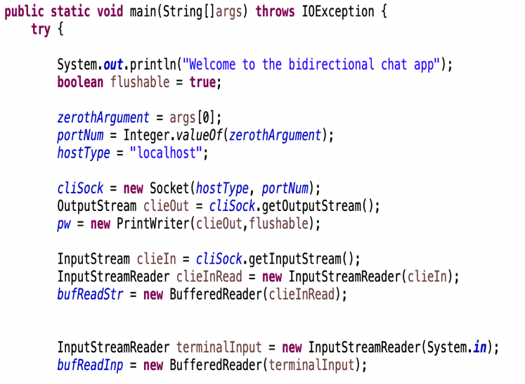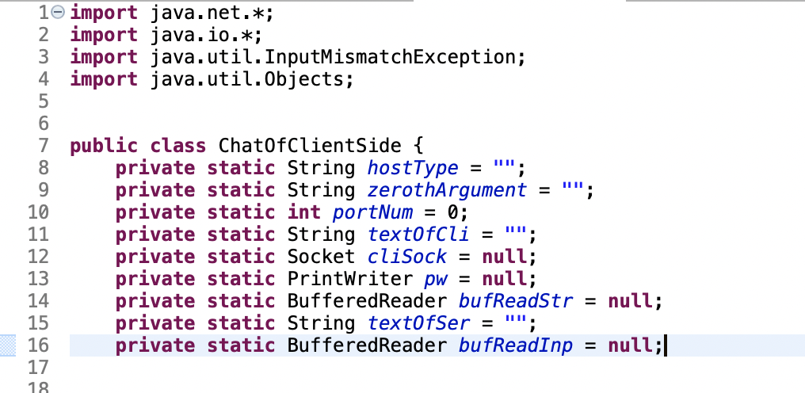

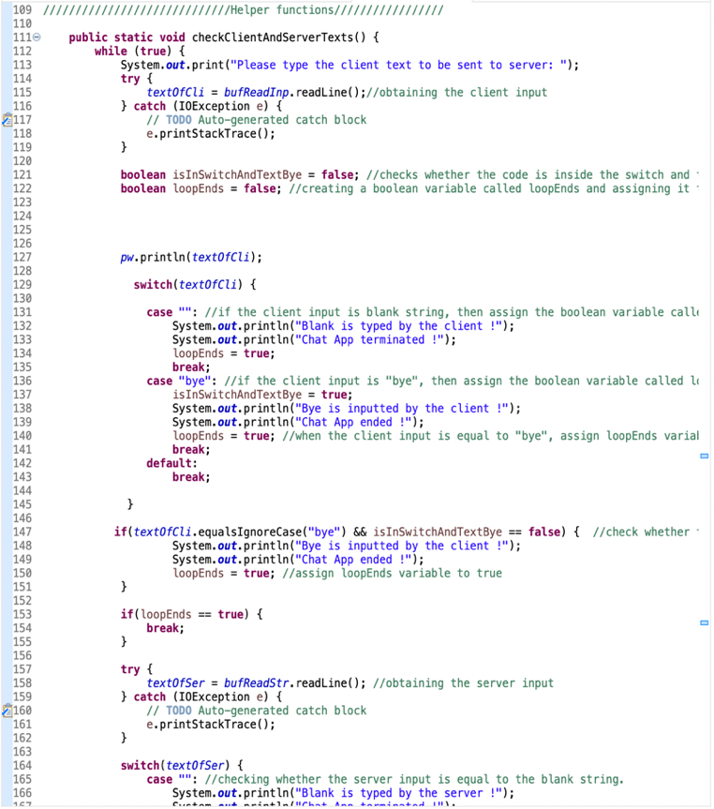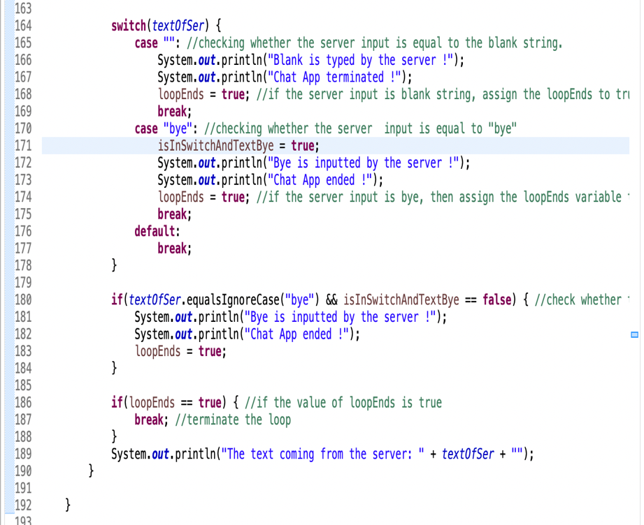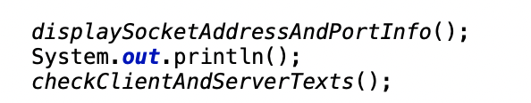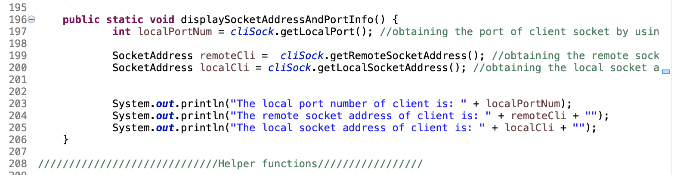

Then, inside the client side code,I have created a method for obtaining the client inputs and keeping track of client inputs & server inputs (See Check Client And Server Texts SS1 and. Check Client And Server Texts SS2). I have obtained the client inputs by using readLine() method. By using seperate switch cases for client texts and server texts, I have checked whether the client input or server input is equal to bye or blank. For terminating the while loop when the input is bye or blank, I have defined a boolean variable called “loopEnds”. I have made this variable true for the client inputs and server inputs which are equal to “bye” or blank. By using the equalsIgnoreCase() method, I have also checked the cases of the client inputs and server inputs equal to “bye”. In these checks, I have made the “loopEnds” variable true. By using println function with the print writer object (pw.println(text)) , I have attached the input of the client to the print writer object. In the server side , I have defined a method which is functionally similar to the method in the above screenshot. Whereas I have taken client inputs in the client side code, I have taken the server side inputs in the server side code.

Check Client And Server Texts SS1

Inside the above method; by using getLocalPort() method, I have obtained the local port number of the client socket. By using getRemoteSocketAddress() method, I have obtained the remotesocket address of client. By using getLocalSocketAddress() method, I have obtained the local socket address of client.

Check Client And Server Texts SS2

After I created the streams, stream readers, and the client socket; I have called the methods called displaySocketAddressAndPortInfo() and checkClientAndServerTexts()in the main method of the client side code.

Next, I have taken the port number as an argument. For that purpose, I have used the Integer.valueOf() method. I have then created the client socket , and the streams & stream readers which will be used to keep track of the client inputs and server inputs.

Here, I have imported the “.net”, “.io”, “.util.InputMismatchException”, and “.Objects” libraries. After that, I have initialized the necessary variables to be used in the client side code.

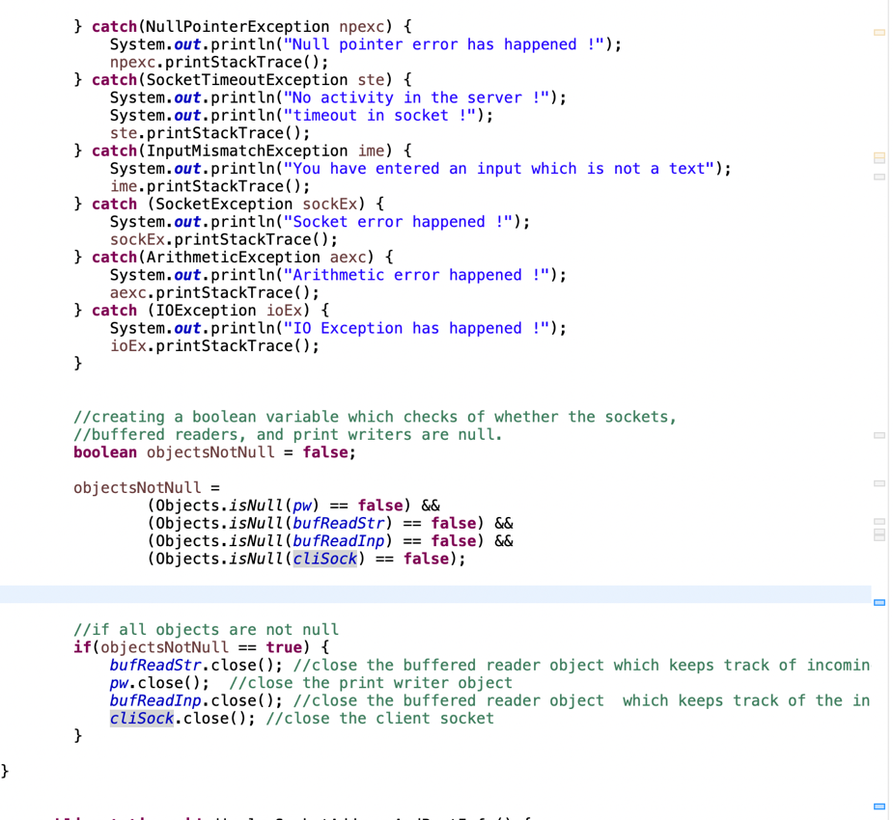

Here, inside the client side code (see Exception Handling and Object Closing SS) , I have handled some possible exceptions. Then, I have closed all buffered reader, print writer, and socket objects.While closing these objects, in order to deal with the timeout situation, I have checked whether these objects are not null by using the isNull method of the Objects class of Java. In the server-side code (see Server Side Code SS2), I have followed the same approach to handle the exceptions and close the objects.

I have handled the exceptions in the catch blocks.

For checking whether the buffered reader objects, print writer objects, and socket objects are null, I have used Objects.isNull() method. If all of the buffered reader objects, print writer objects, and socket objects are not null, then I have closed these objects by using close() method.

Server Side SS1: I have set the timeout of the server by using setSoTimeout() method. I have dealed with exceptions in seperate catch blocks. For converting the command line arguments to integers, I have utilized Integer.valueOf() method.

Server Side SS2: Inside the method called “showSocketAddressAndPortInfo()”, by using the getRemoteSocketAddress() method, I have displayed the remote socket address of the client socket. By using getLocalSocketAddress() method with client socket and server socket, I have displayed the local socket addresses of them.

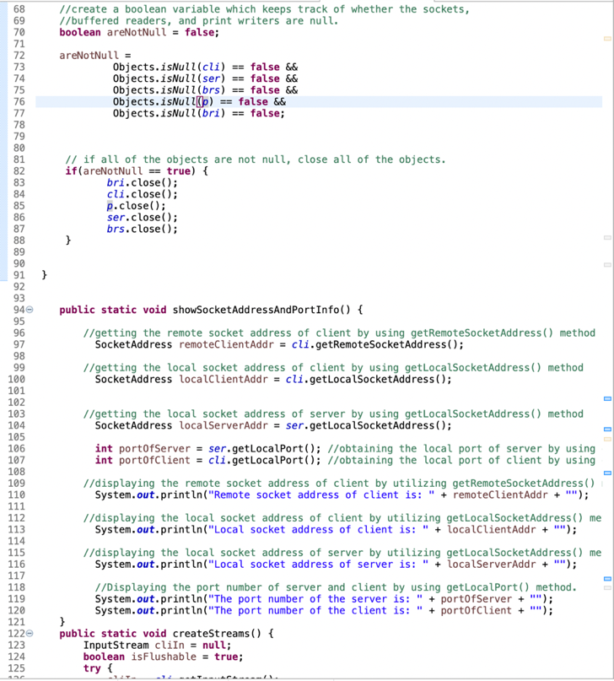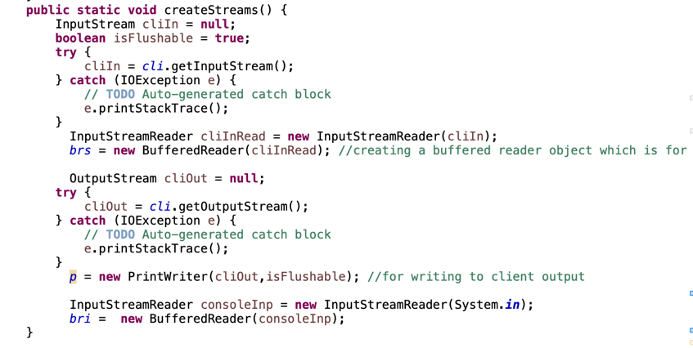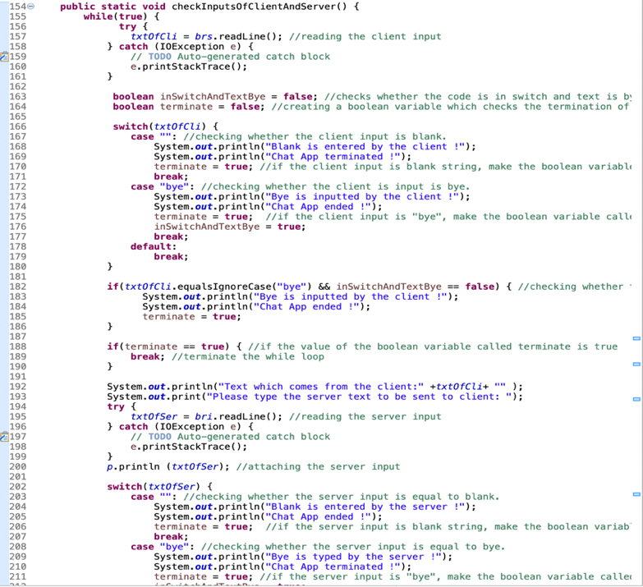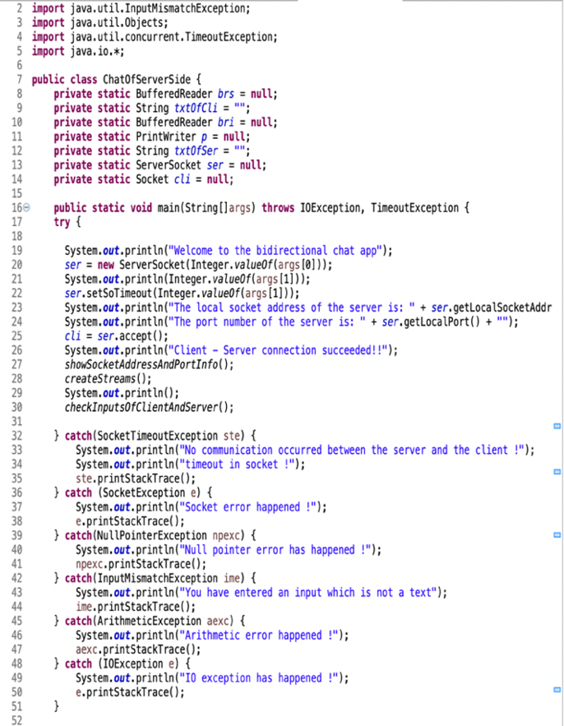

Server Side Code SS2

Continuation of createStreams() function

Server Side Code SS3

Server Side Code SS1

Exception Handling and Object Closing SS

In the server-side code, I have taken the port number and timeout duration as arguments. I have taken the port number as the first argument and the timeout duration as the second argument. Since these arguments are both String , I have converted them to integer by using Integer.valueOf() function. After that, I have displayed the local socket address (by using getLocalSocketAddress() function) and port (by using getLocalPort() function) info of the server. Next, by using accept() function, I have made the connection between the client and server. Then; I have created a method for displaying the remote socket address & local socket address of client, local socket address of server, the port number of server, and the port number of client. I have used getRemoteSocketAddress() method for displaying the remote socket address of the client, getLocalSocketAddress() method for displaying local socket addresses, and getLocalPort() for displaying port numbers. Then, inside a method called “createStreams(), I have created the streams which are used for keeping track of the client inputs and server inputs. Then; inside another method, I have obtained the client inputs with readLine() method. After that, I have checked whether the client inputs or server inputs is equal to “bye” or blank. I have done these checks in two seperate switch statements. By using equalsIgnoreCase() method, I have also checked whether the client input or server input is equal to “bye” regardless of the case of “bye”. I have defined a boolean variable which checks whether the input is “bye” and the code enters to the switch statement. Finally, inside the main method, I have closed all socket objects, print writer objects, and buffered reader objects. In order to handle timeout situation, while closing these objects, I have checked whether these objects are null by using Objects.isNull() method.

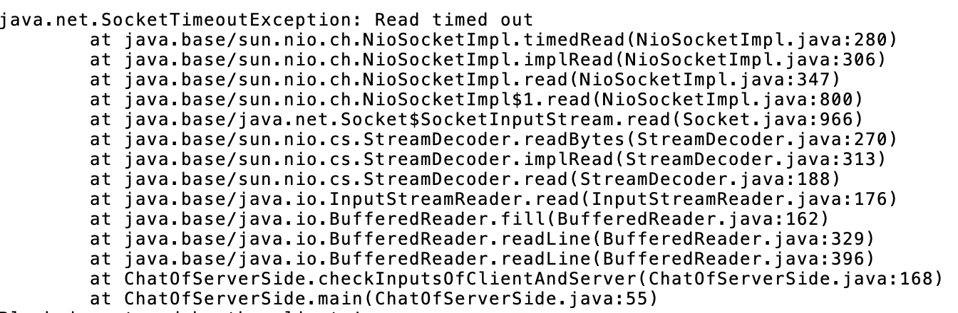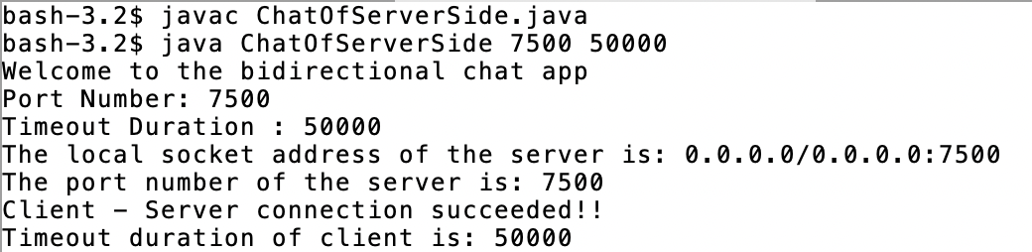

The figure above is the read timeout output from the server side terminal. (If we specify the timeout value of the client after accepting the client in the server side code). For specifying the timeout duration of client, cli.setSoTimeout(Integer.valueOf(args[1])) method should be used. Since the type of an argument which comes from the command line is String, we should convert it to integer by using the method called Integer.valueOf(args[1]). For making timeout duration equal to second command line argument, we get the timeout duration from the command line input by using args[1]. After the read timeout output in the server side terminal, the program will continue to want an input text from the client side. (This above screenshot is taken from the output (output of the run of source code called called ChatOfServerSide.java) in the server side terminal.). For the above screenshot, client is connected to server but client does not provide any input text.

Screenshot which shows the value of the client timeout duration after its specification with cli.setSoTimeout method.

(This screenshot shows the non-default timeout settings of client)

NOTE1: Timeout duration : 50000 (refers to server’s timeout duration)

NOTE2: Timeout duration of client is: 50000 (refers to client’s timeout duration)

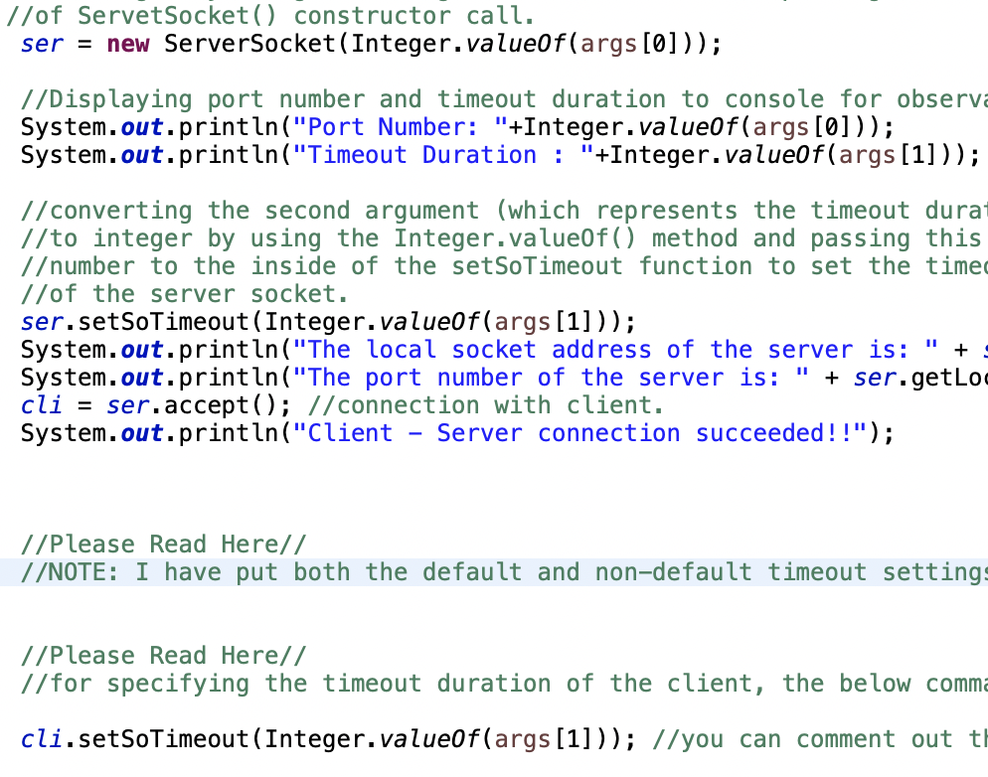

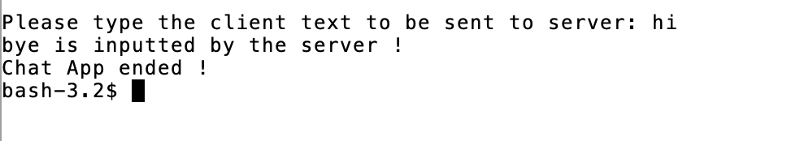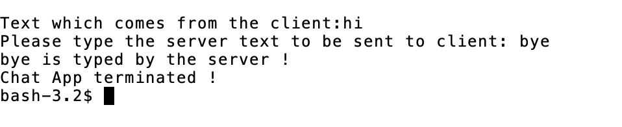

Screenshot which shows the commands to compile and run the source code called ChatOfClientSide.java.

(This screenshot is taken from the client-side terminal).

Screenshot which shows the commands to compile and run the source code called ChatOfServerSide.java

(This screenshot is taken from the server-side terminal).

SCREENSHOTS OF THE COMPILATION AND RUNNING OF CLIENT SIDE CODE AND SERVER SIDE CODE

This screenshot is taken from the client-side terminal. After server types bye to the terminal, client is informed from that. Moreover, the messages which are shown in this screenshot are printed to the client-side terminal.

Screenshot which shows the how to specify the value of client timeout duration (Please see cli.setSoTimeout(Integer.valueOf(args[1]))

Screenshot which shows the keyword I used for ending the program and the messages displayed in the server-side terminal at the end of the program (This screenshot is taken from the server-side terminal).

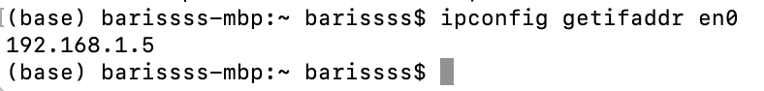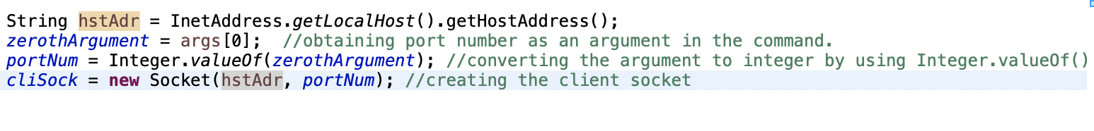

**NOTE: Please have a look at the places which are marked with “Please Read Here” in the code.**

The output of the run of "ipconfig getifaddr en0" command in macos terminal.

(Without Bonus SS), Creating Client Socket with localhost host type (This screenshot is taken from the client-side code (Namely ChatOfClientSide.java)).

Bonus SS (This screenshot is taken from the client-side code (Namely ChatOfClientSide.java)).

To make the client and server run on different machines, inside the client-side code (namely ChatOfClientSide.java), we should initially obtain the host address of the ip address of server. For obtaining the host address of the ip address of server, we should use the InetAddress.getLocalHost().getHostAddress() method. This host address can also be obtained by typing the command called “ipconfig getifaddr en0” command to terminal in Macos operating system. Subsequently; inside the client-side code, as the initial argument, we should pass the host address to the Socket constructor call of the client socket.

Instead of the process in the figure named “Without Bonus SS”, we can perform this process like in the figure named “Bonus SS” (below figure).

For compiling and running the client-side and server-side codes, we can follow the same approach that I have explained in the Read Me section of this report.

**BONUS PART:**